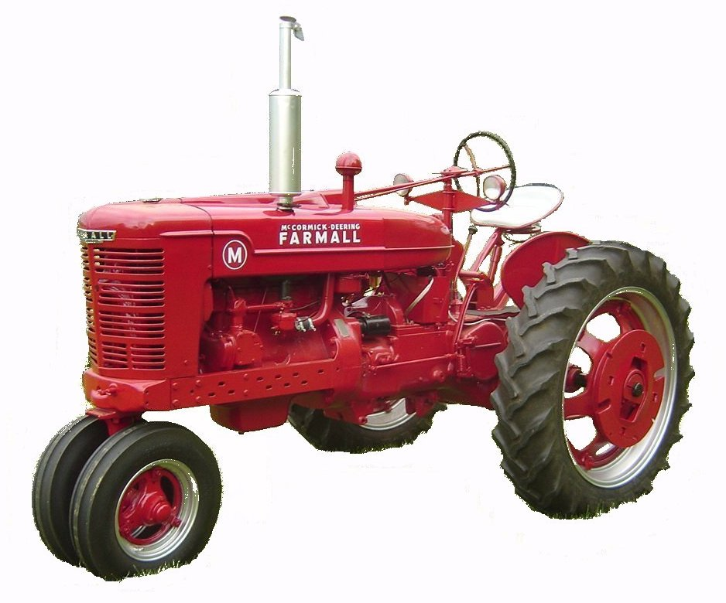
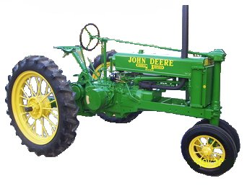

F O O T H I L L S

ANTIQUE POWER ASSOCIATION
ESTABLISHED 2003

May 2017
Dear Members,

It is Show time!!!
Since time is short, this newsletter is abbreviated to give you the critical information concerning the show – primarily the rules & reg’s so they are fresh in our minds. We pray everyone has a safe and wonderful time at the show and we pray for good weather so as many people can enjoy it as possible.

--- --- --- From the May Meeting --- --- ---
- We continue praying for those of our number – our friends and family members, who have pressing needs. We pray, not because our words will change their circumstances, but because we trust The One to whom we pray, for He is The One who has promised.

  - Reba Reinhardt
  - Jan Minyard
  - Kay Nash
  - Gary Setzer & family
  - Horace Isenhour
  - Doug Huffman
  - Jacqueline Hilliard
  - Ann Little
  - Kenneth Beach

  - Vee Williams
  - Lorna Sheets
  - Billie Sue Goforth
  - Steve Hefner
  - Wade Hefner
  - Norris Turner
  - Terry Martin
  - Eugene Hartley
  - Ira & Ann Cline
  - Howard Cooper
  - Kelly Blanton
  - Rev. Bobby Langston
  - Don Johnson
  - Carl Porter
  - Jane Abernathy
  - Kay Nash
  - Daniel Schronce
  - Rick & Chastity Bumgarner

--- --- --- UP-COMING EVENTS --- --- ---

May 19-20 Newton FAPA show
June 1 Sig’s June monthly meeting
June 10 Newton CVHA Harvest Show
June30-July4 Denton Southeast Old Thresher’s Reunion

President: Kevin Black 828-464-1950 Vice Pres: Wilson Sigmon 828-256-2176
Treasurer: Kermit Nash 828-459-9616 Secretary: David Setzer 828-850-4943
Show Chair: Teddy Hefner 828-310-5525 Asst. Show Chair: Anthony Austin 828-302-5326
Asst. Secretary: Kevin Sigmon 828-320-1419

Board of Directors: Phillip Spencer, Howard Reinhardt, Ned Story, Teddy Hefner, Tim Hollar, Butch McIntyre

Foothills Antique Power Association
5851 St. Peter’s Church Road, Conover, NC 28613 -
Foothillsantique.com

Foothills Antique Power Association 14th Annual Power Show May 19 – 20, 2017

- Set-up time at the American Legion Fairgrounds will begin Thursday afternoon May 18th after the Flea-market clean-up has been completed and the grounds have been prepared. Actual time for opening the gates for setup may be between 4 or 5PM depending upon when clean-up is completed. If it is finished early, the time can be moved up.
- Spaces in the main exhibit area may be reserved by members in good standing (dues paid). These spaces are to be occupied by 12 noon on Friday May 19th or they will be forfeited for the duration of the show (unless your intent to fill them after that time is communicated to the reserved space coordinator – Anthony Austin (828) 302-5326).
- All members are to be aware of and adhere to the safety requirements for the show.
- All members are called upon to function as safety monitors by presenting your own exhibits in a safe manner and helping each other do the same.
  - All equipment is to be chocked when parked. Chocks will be available if you have none.
  - Fire extinguishers are to be ready at hand.
  - Be aware of and yield to pedestrians when driving any vehicle on the grounds.
  - Demonstrations should be roped-off to keep little fingers on little hands where they belong.
- Plenty of parking is available, but we need to utilize it wisely.
  - Trailers should be parked in the area below the livestock barn, outside the gate and towards the far end of the camping area.
  - Towing vehicles should be parked in the general parking area.
  - The area next to the pulling track is for pullers (Friday & Saturday)
- All exhibitors are encouraged to register.
- All exhibitors are encouraged to operate their equipment during the show except for two specific times. During these times, all engines, tractors, mowers, etc. are requested to be turned off.
  - During opening ceremonies on Saturday morning.
  - During Sunday morning church services.
- The route for the Parade of Power will be marked off with signs. Everyone should begin by exiting the Main Exhibit area through the pulling track parking area, cross the main road and proceed through the main parking area to the back gate. DO NOT proceed into the food court area until directed.
- This is our show. That means we are host to the public and to those who come to exhibit with us. It is up to every one of us to do what we can to make it a memorable experience for all who come. Each member is encouraged to do their part – no task is too small or menial to be worthwhile and every person is worthy of a smile or a helping hand.
- Basic schedule of events
  - Friday: Lawn mower pull - 7PM
  - Saturday:
    - Opening Ceremony - 9AM,
    - Kiddie Pull – 10AM,
    - Demonstrations – 10AM thru mid-afternoon
    - Parade of Power – 1PM
    - Tractor Rodeo – 3PM
    - OTTPA Truck/Tractor Pull – 4PM
  - Sunday:
    - Church service – 9:30AM

☺ ☺ !!!!! HAPPY BIRTHDAY !!!!! ☺ ☺


May Birthdays

1 – Ben Elmore
2 – Allan Keller
5 – Butch McIntyre
9 – Danny Joe Little
9 – Marry Matthews
10 – Roger Matlock
11 – Tony Sigmon
13 – Keith Shronce
14 – John Bumgarner
16 – Andy Parsons
21 – Michael McAlister
24 – Billie Herman
26 – John Looman
29 – Carroll Reed
30 – Myron Yount


June Birthdays

1 – Mark Cunningham
2 – Ned Story
5 – Butch McIntyre
9 – DannyJoe Little
9 – Barry Matthews
10 – Roger Matlock
11 – Tony Sigmon
13 – Keith Schronce
14 – John Bumgarner
16 – Andy Parsons
21 – Michael McAlister
24 – Billy Herman
26 – John Looman
29 – Carroll Reed
30 – Myron Yount

-- --- --- THE CLASSIFIEDS --- --- ---

Is there anything you would like to sell or are you looking for something special? List it here.
(Item listings will run for 3 months before expiring. Let us know when an item is sold or bought.)

FOR SALE

Allis-Chalmers G taillight, NOS, Butch Fox (828) 4566-3940 (17-01)

A Farmall l948? $800.00 - Hal Lail, 465-1147 (17-03)

Bolens Ride Master, all original, $700 - Butch Fox (828) 4566-3940 (17-01)

Wards walk-behind tractor 3-spd, all original - Butch Fox (828) 4566-3940 (17-01)

John Deere grain drill, 28-disc - Scott Carrigan, (Stony Point) 445-1069 (17-04)

Ford 9N + bushhog, $1100, Tim Taylor, (828) 302-1012, (17-04)

-- --- --- Something to Think About for the Show--- --- ---
We are all proud of the things we display at our show and, in quite a few cases, we are proud of what we have accomplished in restoring or repairing the equipment we display and operate. But is pride the only reason we do it?
We enjoy the fellowship with one another, seeing friends we’ve not seen since last year, meeting new people, and it is a great time to do so, but can this not be done at another time?
We have a tremendous opportunity to show-off our treasures to each other and to strangers, but it is an even greater opportunity to display something even more profound and important – something that requires no gasoline. We, as Christians, have something wondrous to share and any real Christian knows enough to share, unless they sleep during the Sunday sermons.
Is all that our Lord did for us worth talking about? Is our Creator worth mention of His name? It is because of God that we have what we have. It is because of Christ that we are here. Should we not, then, do what we do and say what we say with honor and reverence where it is due?

God bless you all.
Hope to see you at the show. Your Secretary, David Setzer

